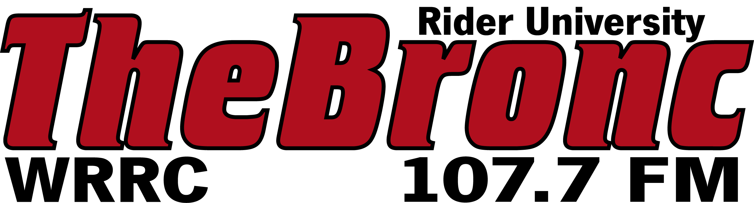

Client: | CAPITAL CAR WASH & DETAIL CENTER
File Name: | CAPITOLCAR_FALL15
Dates:
Writer: | MAZZIO
Length: | 60

capitol car wash covers AND OTHER PROGRAMMING ON 107.7 THE BRONC IS UNDERWRITTEN BY CAPITAL CAR WASH and detail center…1617 PRINCETON AVENUE, LAWRENCEVILLE. you may not realize it, BUT SUMMER REALLY TAKES ITS TOLL ON YOUR CAR. as the seasons change, it’s TIME TO GET YOUR vehicle IN TIP-TOP SHAPE. LET CAPIToL CAR WASH TAKE YOUR SUN-RAVAGED CAR AND TRANSFORM IT INTO A SPARKLING WORK OF ART! FROM POLLEN AND SUMMER STORMS, TO CAKED ON “PRESENTS” FROM SEAGULLS DURING YOUR TRIPS TO THE JERSEY SHORE, CAPIToL CAR WASH HAS YOU COVERED--covered in suds! CAPIToL CAR WASH and detail center’s exterior, full, royal, supreme, ultimate and elite service washes GET YOUR CAR CLEAN-- all while USing only THE HIGHEST QUALITY PRODUCTS IN THE AUTOmotive INDUSTRY TO KEEP YOUR VEHICLE LOOKING ITS BEST INSIDE AND OUT. and with additional SERVICES that RANGe FROM spotless EXTERIOR POLISHES TO COMPLETE “look-like-new” AUTO DETAILING, THERE’S A SERVICE FOR EVERY PRICE POINT AND EVERYONE. so RINSE OFF THE LAST BIT OF SUMMER FROM YOUR car AND GET READY FOR A NEW SEASON WITH CAPIToL CAR WASH AND DETAIL CENTER--five-time winner of the trentonian’s reader’s choice award! FOR MORE INFORMATION ON ALL OF CAPIToL’S TOP-NOTCH SERVICES online it’s CAPITOLCARWASHNJ.COM.

