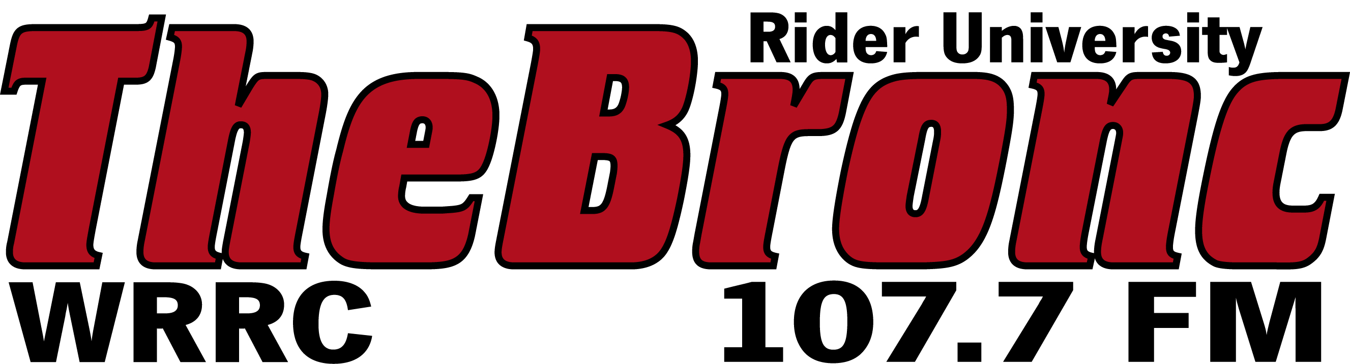

Client: | CAREER SERVICES
File Name: | JOB_FAIR
Dates:
Writer: | MAZZIO
Music:
Length: | 60

LET’S FACE IT, WE’VE ALL BEEN STUCK IN A RUTT WHEN IT COMES TO FINDING A JOB AT SOME POINT IN OUR LIVES; AND DECIDING WHERE TO START IS AN UPHILL BATTLE. LUCKILY FOR YOU, RIDER IS HERE TO MAKE YOUR JOB HUNT SO MUCH EASIER! STOP BY THE ON CAMPUS JOB FAIR SEPTEMBER 17TH AT 11:30 IN THE CAVALLA ROOM, WHERE YOU CAN FIND PLENTY OF OPPRITUNITIES FOR ON AND OFF CAMPUS JOBS! SPONSORED BY FINANCIAL AID AND CAREER SERVICES, RIDER’S JOB FAIR HAS LESSONS ON HOW TO NAVIGATE THE BRONCS CAREER LINK TO MAXIMIZE YOUR JOB SEARCH AND LEARN ALL ABOUT THE CAMPUS’ FEDERAL WORK STUDY. THERE WILL ALSO BE OFF CAMPUS REPRESENTITIVES THAT HAVE JOB OPENINGS SPECIFICALLY FOR COLLEGE STUDENTS. WITH SO MANY OPTIONS FOR EMPLOYMENT ALL IN ONE PLACE, JOB SEARCHING HAS NEVER BEEN SUCH A BREEZE! SO DON’T JUST SIT AROUND AND WISH YOU COULD BE WORKING--LET RIDER BRING JOB OPPRITUNITIES TO YOU—HEAD ON DOWN TO THE ON CAMPUS JOB FAIR SEPTEMBER 17TH AT 11:30 IN THE CAVALLA ROOM AND SEE WHAT OPPRITUNITIES AWAIT YOU. SEE YOU THERE!

